Robust SINS/GNSS Integration Method for High Dynamic Applications

Falin Wu¹, Hengyang Zhao¹*, Yan Zhao¹, Haibo Zhong²
¹School of Instrumentation Science and Opto-electronics Engineering,
Beihang University, Beijing 100191, China

²Space Star Technology Co. Ltd, Beijing, 100086, China

*Corresponding author, e-mail:hengyang178@163.com

Abstract
As high dynamic movement is always accompanied by colored noise which lacks of mathematical model, traditional Kalman filtering based on an assumption of white Gaussian noise always faces serious divergence. To enhance the performance in high dynamic environment with uncertain colored noise, a kind of robust filtering based on H-infinity technology is developed. State model of the algorithm is derived from SINS error propagation. Both position and velocity errors are used as the measurements. A simulation system which includes a tri-axial turntable and a GNSS signal simulator is used to verify the integration design under high dynamic environment. Simulation results proved that both the accuracy and robustness of the integration design have been improved significantly.

Keywords: SINS/GNSS integration, high dynamic, H-infinity Kalman filtering

Copyright © 2014Institute of Advanced Engineering and Science. All rights reserved.

1.Introduction
Strapdown Inertial Navigation System (SINS) is a kind of dead reckoning method based on Inertial Measurement Unit (IMU) . As the navigation error will get accumulated, the precision of IMU determines the navigation effect mainly. Global Navigation Satellite System (GNSS) is a kind of high precision positioning solution which could provide position and velocity information by a single receiver . But the usage of GNSS is limited because of the signal attenuation in urban canyon or situation with strong electromagnetic interference. Furthermore, the low output rate of GNSS limits its usage in high dynamic environment. SINS/GNSS integration mixes their advantages and disadvantages respectively where the Kalman filtering (KF) is commonly used .
High dynamic movement is always accompanied with uncertain colored noise . However, traditional Kalman filter relies on the assumption that both process noise and measurement noise are uncorrelated white Gaussian noise which will result in the divergent of navigation results. Technologies such as robust filtering has been developed to enhance navigation performance under high dynamic environment . H-infinity filtering is a kind of robust filtering technology which could retard filtering divergence effectively in colored noise environment . There is no requirement of noise priori knowledge but just having finite bounded energies. H-infinity filtering based on traditional Kalman filtering does not destroy the linearity and only need the transformation of the covariance matrix calculation.
In this paper, a kind of H-infinity Kalman filter algorithm for SINS/GNSS integrated navigation system is designed. The process model is based on SINS error propagation. Errors of both position and velocity are used as measurements. H-infinity filtering was used to enhance system robustness. At last, a comparison of H-infinity Kalman filtering with the traditional Kalman filtering has been drawn using a hardware-in-the–loop simulation system.

2.Integration Design
Structure of the integration design is shown in Figure 1.

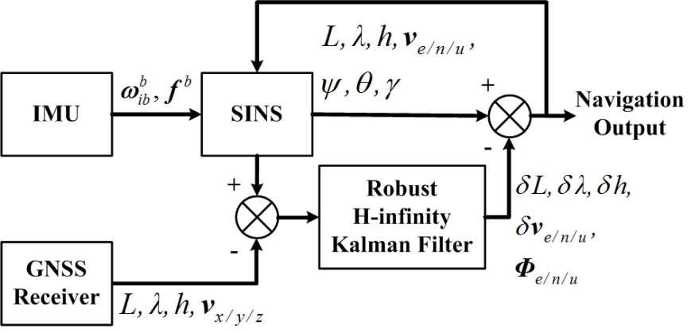

Figure 1. Integration structure

SINS algorithm is applied based on gyroscope angular velocity 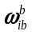 and accelerometer specific force 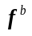 which acquired from IMU. Errors between SINS and GNSS receiver outputs are used as measurements of the filter. Filter estimation outputs will modify the SINS outputs which used as the final outputs and feedback to the next SINS iteration at the same time. Beside these, , and are latitude, longitude and altitude with 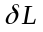, 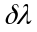 and 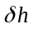 as the errors. 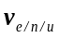 are velocities in geographic coordinate (i.e., east, north and up) with 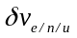 as the errors. , and are craft attitude (i.e., yaw, pitch and roll) from frame (True frame or navigation frame) coordinate to frame (Body frame or craft frame) coordinate. 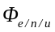 are misalignment angles from frame to frame (Computer frame) coordinate . 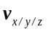 are velocities in earth fixed coordinate as parts of GNSS receiver outputs.

2.1.ProcessModel
Process model of the SINS/GNSS integration is



where is the estimation state variable with covariance matrix .

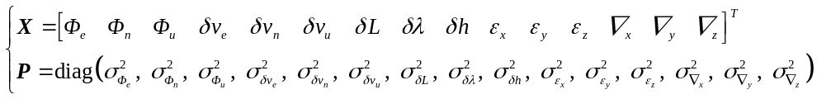

where 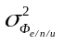, 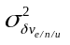 and 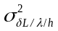 are variance of misalignment angles, velocity errors and position errors. 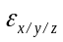 and 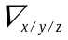 are gyroscope drift and accelerometer bias at frame coordinate with variance 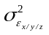 and 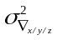.
is additive zero mean white Gaussian noise of the IMU with covariance matrix .

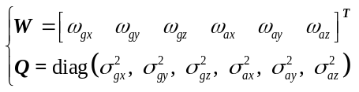

where 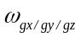 and 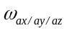 are gyroscope and accelerometer noise process with variance 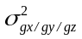 and 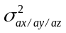.
Process noise input matrix is given as

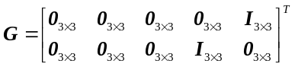

State transition matrix could be extracted from propagation of misalignment angles, velocity errors, position errors and IMU errors which can be expressed as below .

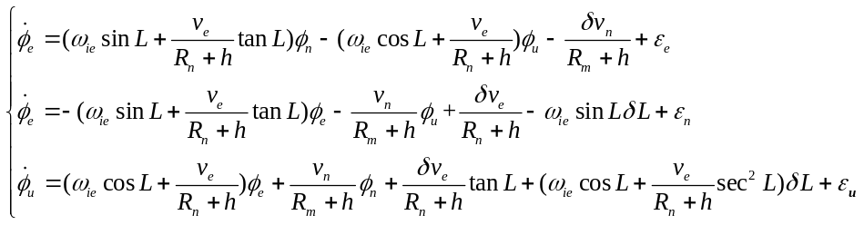

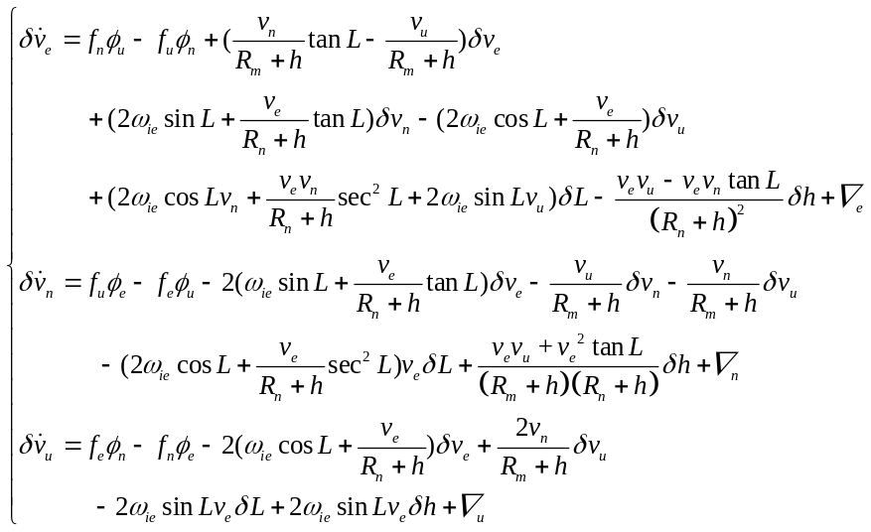

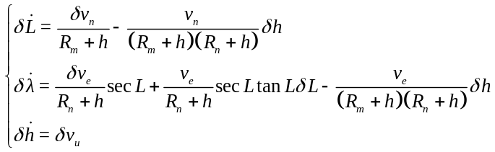

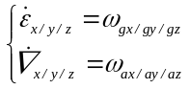

where 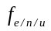, 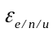 and 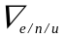 denote the specific force, gyroscope drift and accelerometer bias at frame, respectively. 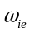 is the rotational angular velocity of the earth. 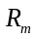 and 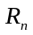 used above are radius of meridian plane and prime vertical plane which can be calculated as

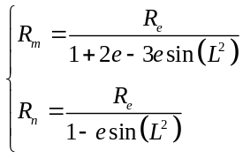

where 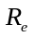 represents the radius of the earth and is the earth eccentrity.

2.2.Measurement Model
Measurement model is based on position error and velocity error at geographical coordinate which can be expressed as

where is the measurement given as

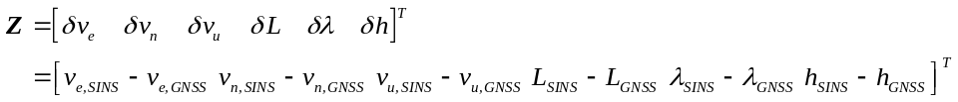

The GNSS receiver has velocity outputs at earth ECEF (Earth Centered Earth Fixed) coordinate as 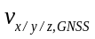 which have to be transferred into geographical coordinate as 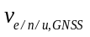.

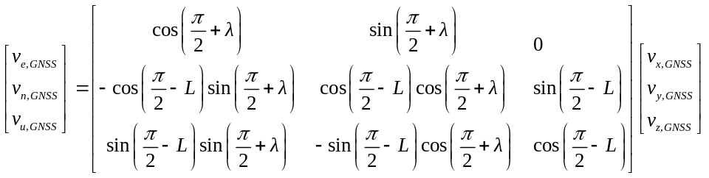

The measurement matrix is given as

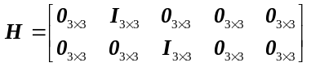

is zero mean white Gaussian noise with covariance matrix .

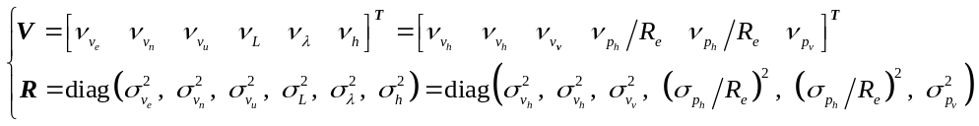

where 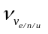 are GNSS velocity measurement noises at geographical coordinate which can also be expressed as horizontal and vertical noise 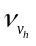 and 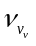 with variances of 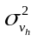and 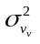.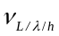 are GNSS geographical position measurement noises transferred from horizontal and vertical noise 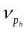 and 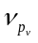 with variances of 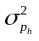 and 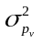.

2.3.H-infinity Kalman Filter
Discretization of the process model and measurement model is represented as

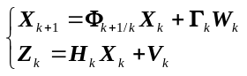

Assume 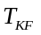 is the calculation period of the Kalman filter. and are given as

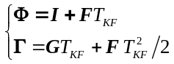

Assume 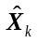 is the state estimation with variance 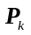, the recursion algorithm of the H-infinity filtering can be expressed as

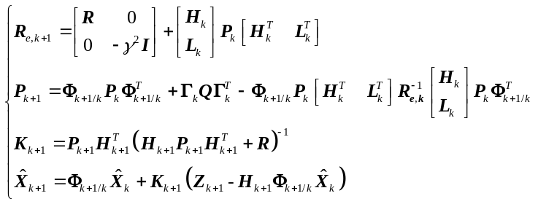

where 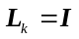 and 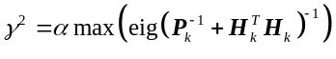. 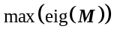 means the maximum eigenvalue of matrix . is a parameter used to guarantee the positiveness of and control the tradeoff between robustness and precision . The value of is set as 10 in this system.

4.Validation and Analysis
To verify the integration design, a hardware-in-the-loop simulation system has been developed . The system includes a IMU, a GNSS receiver, a trajectory simulator, a tri-axial turntable, a GNSS signal simulator and a navigation computer as shown in Figure 2.

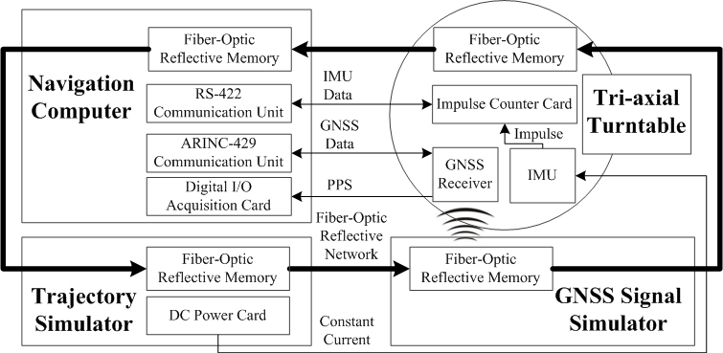

Figure 2. Simulation system structure

The system is built on annular fiber-optic communication network to ensure instantaneity . The IMU contains a tri-axial fiber-optic gyroscope and a tri-axial pendulous integrating accelerometer with output frequency of 100Hz. The GNSS receiver outputs navigation data and PPS (Pulses Per Second) at frequency of 10Hz. The accelerometer outputs desired acceleration under external current injection which comes form three electric isolated channels on the DC power board . Impulse counter board is used to receive and transform continuous impulses come from the IMU . The navigation computer is used to receive and synchronize data as shown in Figure 3 and implement the integration algorithm.

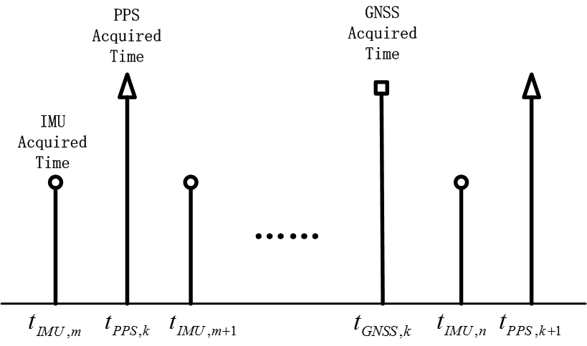

Figure 3. Time synchronization diagram

The basic SINS algorithm will be done firstly when the IMU data has been acquired. Assume the SINS has output of 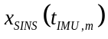 and 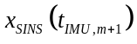 at time 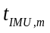 and 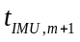. So navigation results at time 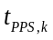 is available by applying binomial interpolation . GNSS data at time could be reckoned by the following operation.

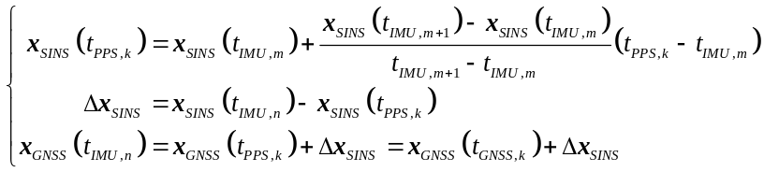

Initial value of matrix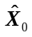 and , alongside with the matrix and are set as below.

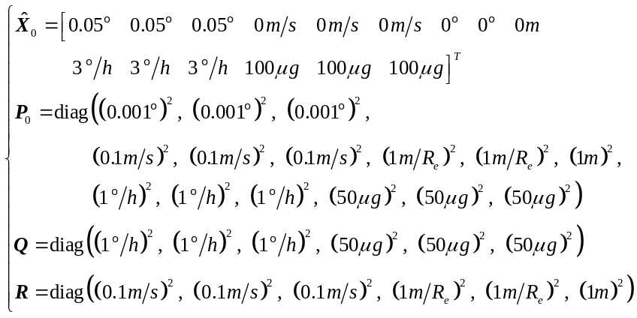

Comparative experiments of H-infinity Kalman filtering and traditional Kalman filtering under high dynamic environment have been conducted using the simulation system. Comparisons of attitude error, velocity error and position error are shown in Figure 4.

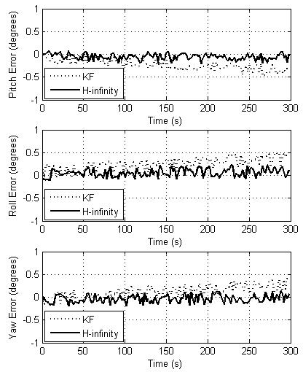

(a) Attitude error
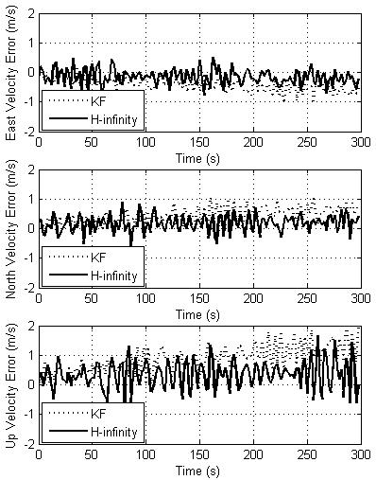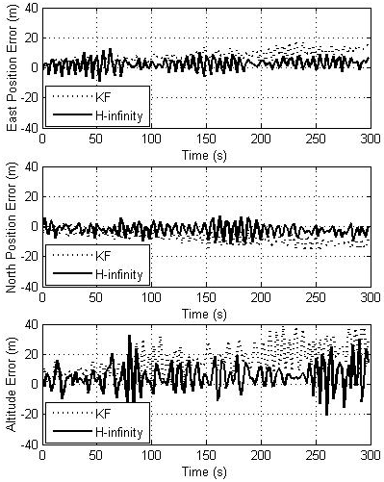
(b) Velocity error (c) Position error

Figure 4. Navigation error comparison

Attitude error mainly caused by colored noise of IMU under high dynamic environment. Comparison of attitude errors indicates that the H-infinity filtering could provide high robustness to some extent. IMU noise and GNSS receiver noise affect velocity and position errors mainly, expecially the up axis results as the height channel of both SINS and GNSS have low precision. Comparison of velocity error and position error indicate that H-infinity filtering has better inhibition of both velocity and position error divergency, and its navigation precision is similar with the traditional Kalman filtering at the same time.

5.Conclusions
This paper presents a kind of H-infinity Kalman filtering algorithm for SINS/GNSS integration method under high dynamic environment. Both designs of the process model and the measurement model are linear, which applys to Kalman filtering or any other linear fusion technologies. A brief design of H-infinity filtering derived from traditional Kalman filtering is used to enhance the robustness performance. Comparative experiments under high dynamic environment based on a hardware-in-the-loop simulation system proved that the H-infinity Kalman filtering has better robustness than traditional Kalman filtering.

Acknowledgment
The research is partial supported by the Open Research Fund of the Academy of Satellite Application under grant No.2014_CXJJ-DH_07, and the Scientific Research Foundation for the Returned Overseas Chinese Scholars, State Education Ministry, China.

References
[1] Titterton DH, Weston JL. Strapdown Inertial Navigation Technology. The Institution of Electrical Engineers. 2004.
[2] Kaplan ED, Hegarty CJ. Understanding GPS: Principles and Applications. ARTECH HOUSE, INC. 2006.
[3] Grewal M, Andrews A. Kalman Filtering:Theory and Practice Using MATLAB. Wiley-IEEE Press. 2008.
[4] Groves PD. Principles of GNSS, Inertial, and Multisensor Integrated Navigation Systems. ARTECH HOUSE, INC. 2008.
[5] Qi W-J, Heilongjiang U, Zhang P, Nie G-H, Deng Z-L. Robust Weighted Measurement Fusion Kalman Predictors with Uncertain Noise Variances. TELKOMNIKA Indonesian Journal of Electrical Engineering. 2014; 12(6); 4692-4704.
[6] Xie L, Soh YC. Robust Kalman filtering for uncertain systems. Systems & Control Letters. 1994; 22(2); 123-129.
[7] Xie L, Soh YC, De Souza CE. Robust Kalman filtering for uncertain discrete-time systems. Automatic Control, IEEE Transactions on. 1994; 39(6); 1310-1314.
[8] Simon D. Optimal State Estimation: Kalman, H∞, and Nonlinear Approaches. New York: Wiley. 2006.
[9] Benson DO. A Comparison of Two Approaches to Pure-Inertial and Doppler-Inertial Error Analysis. Aerospace and Electronic Systems, IEEE Transactions on. 1975; AES-11(4); 447-455.
[10] Zhou W, Dalian University Of T, Ma H, Wu S, Meng N. INS/GPS Integrated Navigation Technology for Hypersonic UAV. TELKOMNIKA Indonesian Journal of Electrical Engineering. 2014; 12(1); 398-405.
[11] Li W, Jia Y. H-infinity filtering for a class of nonlinear discrete-time systems based on unscented transform. Signal Processing. 2010; 90(12); 3301-3307.
[12] Lei HR, Chen S, Chang Y, Wang L. Research on the Hardware-in-the-Loop Simulation for High Dynamic SINS/GNSS Integrated Navigation System. Advanced Materials Research. 2013; 846-847; 378-382.
[13] Zhao K-R, Xu S, Ye Q, Li Y. Design and realization of flight simulation system based on Virtual Reality technology. Control and Decision Conference (CCDC), 2011 Chinese. Mianyang, China. 2011; 4361-4364.
[14] Niu X, Yan K, Zhang T, Zhang Q, Zhang H, Liu J. Quality evaluation of the pulse per second (PPS) signals from commercial GNSS receivers. GPS Solutions. 2014; 1-10.
[15] Li G, Mu J, Xu H. Measurement study for accelerometer based on injection current. Journal of Astronautic Metrology and Measurement. 2000; 20; 6-7.
[16] Xie W, Cai Y, Yao J, Xin C. Design and implementation of the LIMU pulse counting system. IET Conference Proceedings. Xiamen, China. 2012; 778-781.
[17] Zhang P, Gu J, Milios EE, Huynh P. Navigation with IMU/GPS/digital compass with unscented Kalman filter. Mechatronics and Automation, 2005 IEEE International Conference. Niagara Falls, Ont., Canada. 2005; 3; 1497-1502.

